NAME: NAVODITAA A.R
ROLL NO: 241901071

4. ANALYZE THE MALICIOUS NETWORK TRAFFIC USING WIRESHARK
DATE: 18/02/2026
Aim:To apply your analytical skills to analyze the malicious network traffic using Wireshark.
Procedure:
- Log into TryHackMe and open the Network Security Essentials room.
- Study basic network security concepts including firewalls, IDS, and IPS.
- Understand common network threats such as malware, phishing, and DDoS attacks.
- Learn monitoring techniques using logs and traffic analysis.
- Explore methods to protect networks from adversaries.
- Complete the tasks and answer the questions in the room.
- Review the summary and confirm completion.
Tasks:
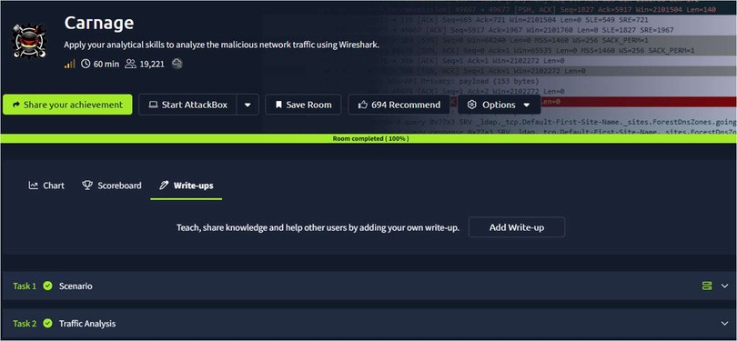
TASK 1 – Scenario
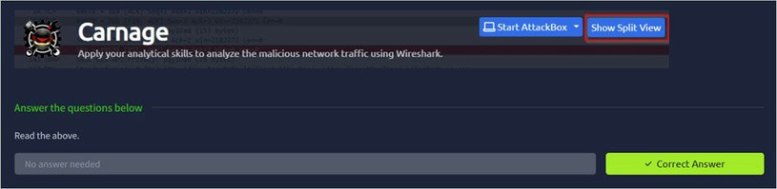

TASK 2 – Traffic Analysis
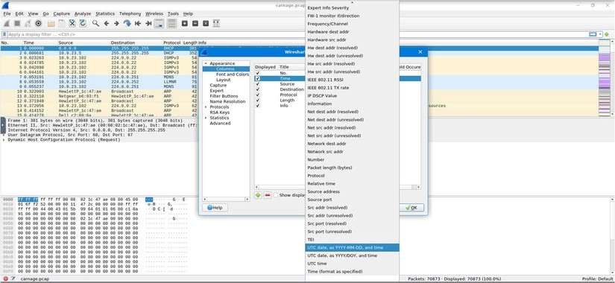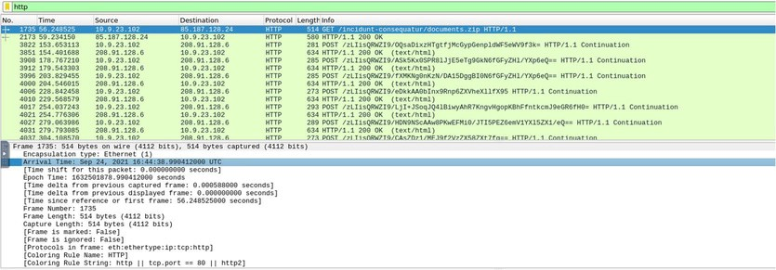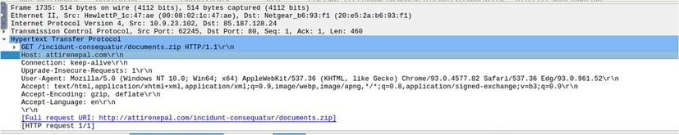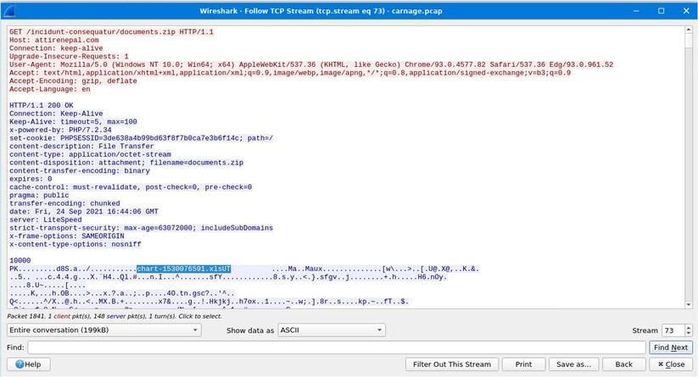
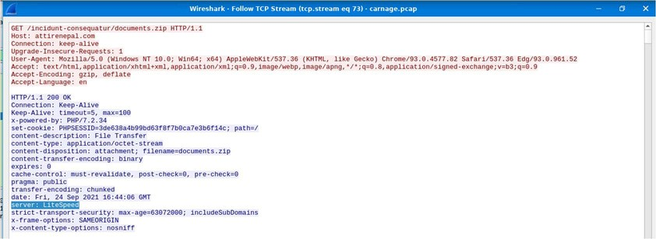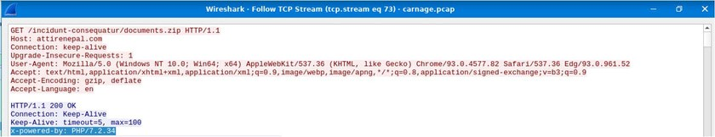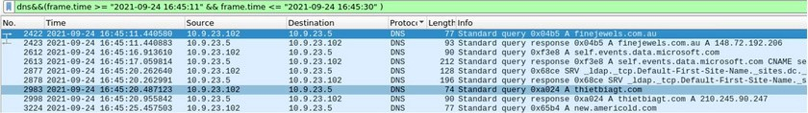
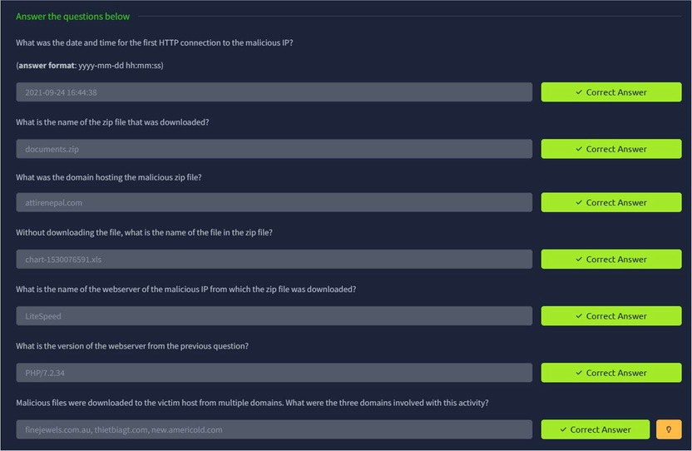
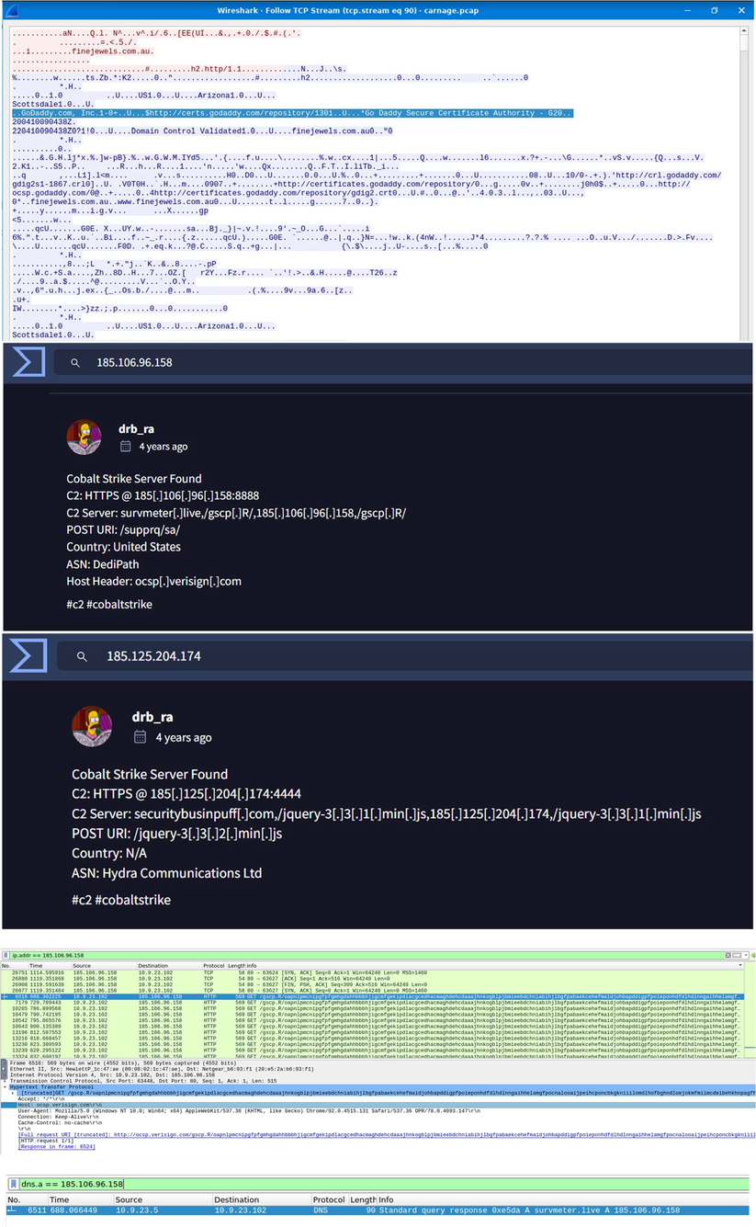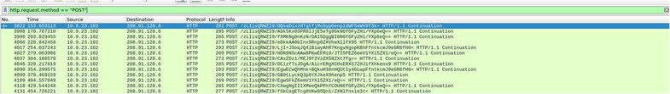
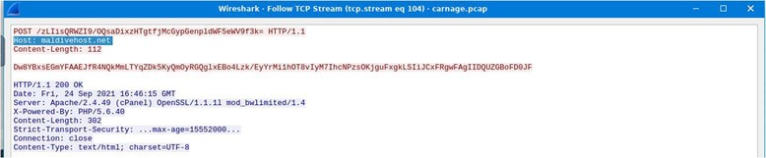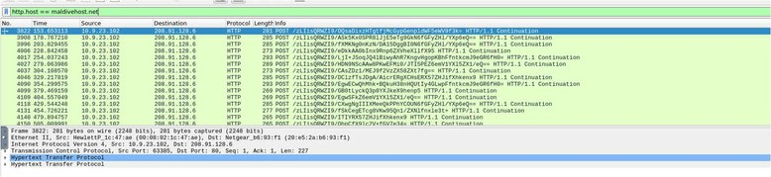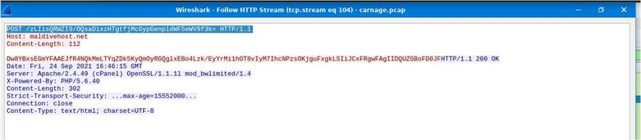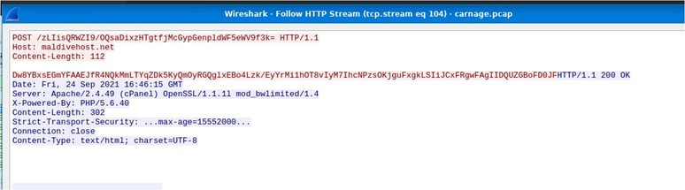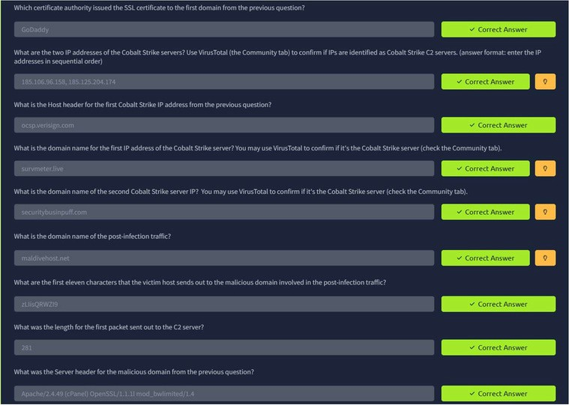
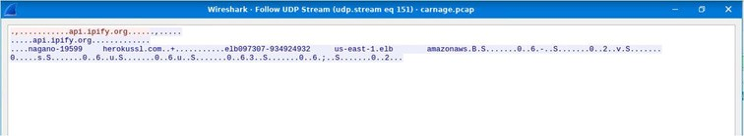
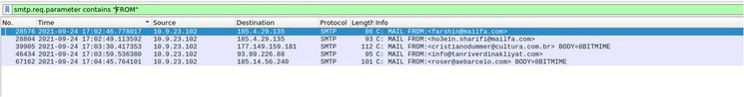
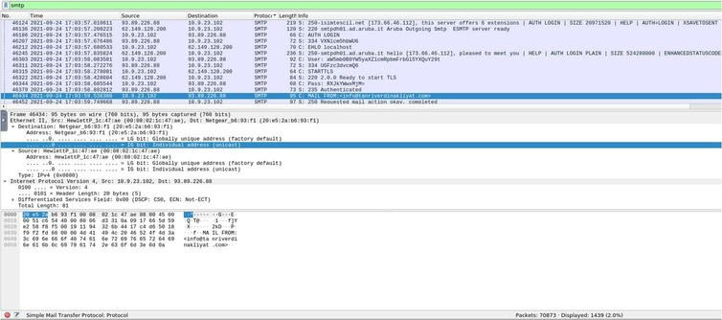
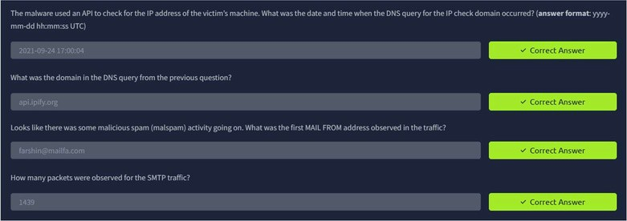
Result:
This the TryHackMe room “Carnage” was completed successfully.

